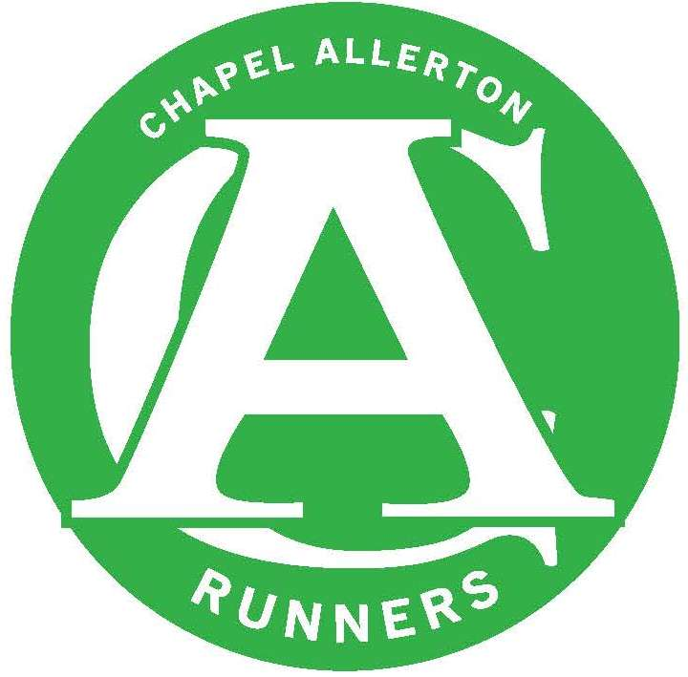
CHAPEL ALLERTON RUNNERS
COMMITTEE MEETING – MINUTES

DATE OF MEETING:9th October 2017

Next Meeting: Monday 13th November 2017

Present: Denise McGeachy Michael Vinegrad Carly Terry, Kath Owen
David Allison Mike Dearden Rob Baxter

Apologies: Marie Leverton, Des Keegan

ITEM | ACTION
AGM | The Committee reviewed the presentation order for 2017 and agreed the format for the AGM.  Actions include:  New Male & Female team captains which will include captaining the PECO teams along with other relay races throughout the race calendar.  An email is to be drafted and sent to the membership about the AGM – what to expect, the benefits of attending and specifically outlining the forthcoming committee roles available all membership invited to discuss committee roles with existing committee members whenever suitable.  Perpetual Trophies need to be returned and make sure that the previous winners details have been engraved on them. This includes, most improved (Mens & Ladies) outstanding achievement, member of the year and M & F club Champs.
Website | It was agreed that we would launch the new website at the AGM as planned and run both sites alongside one another with a view to welcoming constructive feedback from members about the new website.  A lot of importance has been placed on the ‘Events’ section of the website and should we need to we will allocate 1 month to each committee member to transfer this data from the ning site to the new wordpress site.
Membership | Kath reported the current number of members at 142 registered members, an increase of 8 new members since the last committee meeting.
Finances | Rob reported current balance as of 30 Sept: money in account £4,530.80 of which £3,216.80 is unattributed  The club finances are healthy and in light of this we will get quotes for a new flag, banner and a branded tent that have the correct web address and logo on.
Committee update | No change since last meeting.
Member of the Moment | A new MoM was agreed – to be announced on the next Newsletter
Training and Coaching | Wednesday nights  EA Coach, Rebecca Gooch has offered to lead warm ups on a Wednesday evening before a club run, starting at 6.15pm. Warm ups are important, so we will go ahead with the warm ups as an option for everyone to join in voluntarily.
Club Development | No update at present.
Forthcoming races, events & socials | AGM –.  Broadcast message to go out to the membership about the significance of the AGM. And the roles that we are recruiting. The event will follow a similar agenda as in previous years.  Carly to look after the social element and fuddle.  YVAA - A discussion was had about registering CAR for the YVAA League for the 2018 season. With a willing volunteer to act as Vets Captain and a higher percentage of qualifying members than expected the committee decided that we will pay the £20 to register CAR for the series. More info on the YVAA is available here: http://www.yvaa.org/grand-prix/  Christmas Party 40 members have said they will attend the event on the club site with 10 already paid.  Halloween Club Run – Set for 1st November with a stop in Chapel Allerton doe a beer mid-run. Fancy dress compulsory (!) with a prize for the best outfit.  PECO – Dates announced & we have offered to support RR at their event held at Roundhay Park on the 7th January 2018.  It was agreed at the meeting that to encourage more juniors to sign up to the junior events (as there is a new rule allowing juniors to take part in PECO as long as they are associated with a registered club) we would go ahead and purchase tops that can be borrowed by the junior runners.
Club Website, Social Media & Marketing | Newsletter  All future content suggestions to be forwarded to Vinny.
Club Champs | No update
GSSC | No matters arising at the moment.
AOB | No matters arising

