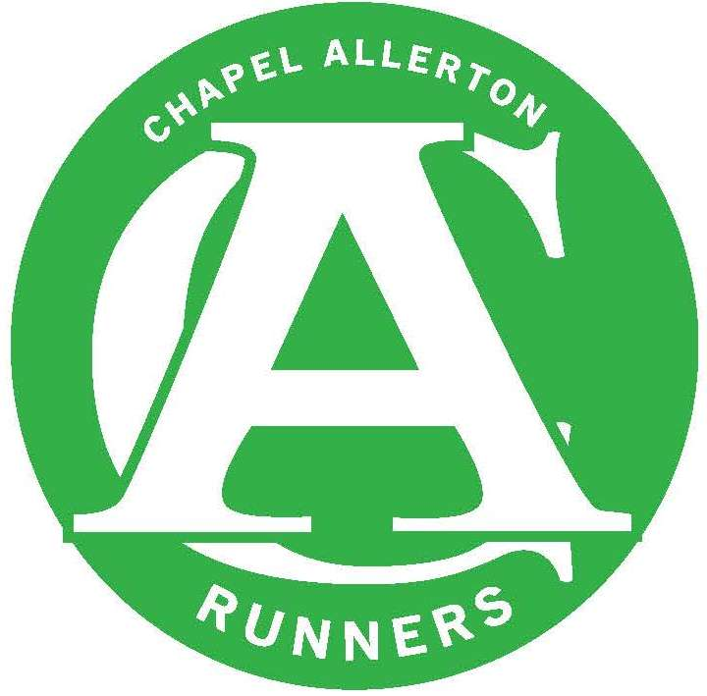
CHAPEL ALLERTON RUNNERS
COMMITTEE MEETING – MINUTES

DATE OF MEETING: 11th June 2018

Next Meeting: Monday 9th July 2018

Present: Denise McGeachy, Kath Owen, Suzzi Garnett, Jen Whiteman, Dan Price, David Allison, Brian Harrold, Carly Terry, Mike Dearden, Rob Baxter

Apologies: None

ITEM | ACTION
Committee | Denise is due to stand down as Club Secretary in September having completed 3 years in the role. Dan has volunteered to take on this role – the committee took a vote and agreed that Dan will take over as club Secretary in September.  DM will remain on the committee and take on Kit and the Newsletter.
Website | Denise has spoken with a work colleague who has offered to help with the website. The Wordpress renewal has already gone through at £250.00 for the year. However, we may not progress with wordpress so Rob will contact them to see if there is a cooling off period.  In the meantime, Denise will message Julie with a suggestion of a club site that we like the look of so she can see what template that is built on. If it’s not Wordpress we will look to cancel that subscription and get a refund.
Membership | - Renewals – 140 members have renewed which is a real success.  - There are a few members that have been identified as having not renewed yet and they will be contacted with a note to let them know that they have 1 week to renew or we will start to retire non-renewing members from the club site and EA.
Finances | Current unattributed funds at circa £2,300.00  DM is to review the situation with getting a new flag as funds have been set aside for this purpose (current flag is out of date)  DM will speak to a colleague who is also on the GSSC committee about getting a new sign for the entrance to the club. The GSSC sign is damaged and CAR would like to have a presence on the entrance sign and with healthy finances it makes sense to team up with GSSC for this.
Member of the Moment | MOM noted and will be announced in due course.
Club Night Comments | - We have been allocated a coach from EA! Dr Andrew Drake will be coming to the club to lead 3 sessions to be held over 12 weeks. Suzzi & Mike are leading. We need to:  - Find out the guidelines on participant numbers, this will help us decide whether we should run the course on a Monday or a Wednesday.  - Find out where we should run the course. i.e. will we need a lit track  - Mondays might not be ideal if the session follows a big race that might have happened on the day before.  - If we need a floodlit track, options are Carnegie or Brownlee Centre. This may incur a cost.  Suzzi will look into these in the first instance and arrange a meeting with Mike, Suzzi & Doctor Drake.
Forthcoming races, events & socials | Beginners  - The final session is this Wednesday – DM to organise Pizza for after the run.  - Most of the vital parkrunner volunteer roles have been filled ahead of the parkrun take over on the 16th June.  - Rebecca is supplying green wristbands for the graduating parkrunners so that they can be identified on Saturday morning.  Events  BMW: Teams have been announced.  Annual Trip  Lisbon won the vote. Marathon, half marathon, 8k race. Weekend of 13/14th October.  Keswick  CAR performed really well at the festival again and hope to retain the Club Cup for the third year in a row!  Socials  CAAF is on Saturday 1st September – form has been filled out to book a stall same place requested as usual.  Chapel Allerton Handicap Race  Has been moved to 16th as previous date of 23rd September clashes with Kirkstall 7. Carly to notify GSSC – event to be created on website.  YVAA  Rob C has volunteered to take on the role as Vets Captain.  Summer BBQ  Date agrees as 8th July and potentially going to make it a sports day as well as a barbeque. Event to be created on the website.  Chapel Allerton Relay Race  Brian and Dave have been looking into race routes and so far Eccup is looking the best option. As a club we now need to understand better how to host a relay race. We will aim to do a dummy run one Wednesday with club members as a trial.  We need to agree a date to run the reccie  We will need a race director  Kath will speak to a local and frequent race host for some pointers.  It would be great to tie in with the Golden Acre Relay and Danefield to create a series of three relay races in the summer.
Kit | DM carried out kit check and will put in an order for vests. Will speak to Wasp about a hoody order as well.
Social Media & Marketing | The 4 mile routes need to be uploaded on the website.
Club Champs | No comments
GSSC
AOB | None

