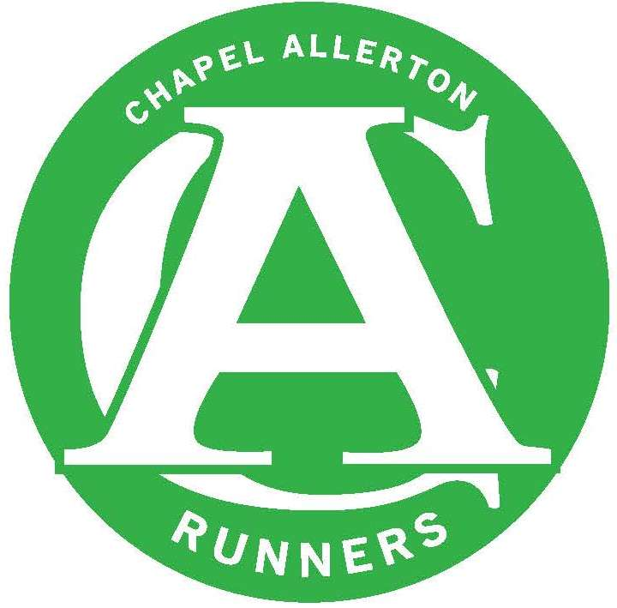
CHAPEL ALLERTON RUNNERS
COMMITTEE MEETING – MINUTES

DATE OF MEETING: Monday 9th July 2018

Next Meeting: September 10th 2018

Present: Denise McGeachy, Kath Owen, Suzzi Garnett, Jen Whiteman, David Allison, Carly Terry, Mike Dearden

Apologies: Brian Harrold, Rob Baxter, Dan Price

ITEM | ACTION
Committee | No updates
Website | Decision was made to stay with the Ning website platform. Denise will speak to Julie about Ning upgrades, timescales, a different picture integration and a change to the current privacy settings so that non members can see the home page (currently can’t)  Need to also investigate website back up solutions in case Ning does have a wobble.
Membership | - Website and EA cull has been carried out. Membership now stands at 140  - It was noted that of new members in the 2016/17 season 50% have not renewed in the 2018/19 season.  - In light of this it was suggested that the committee invite a new member to join in a non-official capacity to represent this segment of the club. This role will be announced on the next club run.  Beginners  Current signals show that the conversion rate from this course might be a bit lower than we hoped. From the next course, we will introduce a crib sheet to introduce all the LIRFs that will lead and assist on the course.  Waiting for feedback from Rebecca from the survey forms.
Finances | Current unattributed funds at circa £2,381.00  Committee members are still waiting for their cards and card readers to be sent by the bank.
Member of the Moment | MOM noted and will be announced in due course.
Club Night Comments | Training  Dr Andy Drake will be coming to do run some sessions on 24th September, 8th October and 22nd October. 2 x tempo session, 1 x hill session. Routes to be confirmed  Need to see if there’s an upper limit on the session. Suzzi will create events. Mike to add to Monday Schedule.  LAN Meeting – David to attend to see if we can get some funding to get a race director.  EA Meeting – Kath attending.
Forthcoming races, events & socials | Annual Trip  David to put out a broadcast message about the trip.  Keswick  Still not had any feedback from the organisers so we don’t yet know if we’ve retained the cup.  Socials  CAAF is on Saturday 1st September – form has been filled out to book a stall same place requested as usual.  Chapel Allerton Handicap Race  16th September GSSC booked.  Chapel Allerton Relay Race  Brian and Dave have been looking into race routes and so far Eccup is looking the best option. As a club we now need to understand better how to host a relay race. We will aim to do a dummy run one Wednesday with club members as a trial.  We need to agree a date to run the reccie  We will need a race director  Kath will speak to a local and frequent race host for some pointers.  It would be great to tie in with the Golden Acre Relay and Danefield to create a series of three relay races in the summer.  Need to speak to Yorkshire Water
Kit | DM carried out kit check and will put in an order for vests. Will speak to Wasp about a hoody order as well.
Social Media & Marketing | The 4 mile routes need to be uploaded on the website.
Club Champs | No comments
GSSC | Field Development: We’ve been approached by GSSC to voice what assets we might want from the club as they work on their development. Our main priorities would be a floodlit track. Sport England have a grant finder that we could approach. We would need to assist with the creation of a ‘bid’ for some funding to allow this development.
AOB | As per GDPR all member data from last year needs to be deleted – Suzzi will action.

